RAG System

What is rag system?
Retrieval augmented generation system is a system that can process the company documents, technical specs with LLM models to provide better and relevant answer from the given documents.

Token – 1 Token is one English word.
Context Tokens – Number of Tokens a LLM can process with single request.
Chunking – Small set of tokens. Let says 1K.
Embedding model – small chunks of tokens from large source documents are converted from English to associated vectors or mathematical representation.
Embeddings/VectorDB – A vector embedding is mathematical representation of words, sentences or even images. CAT -> [34,8,7.5]. Each number is called dimensions. Words with similar semantic meaning tend have dimensions that are closer to each other.
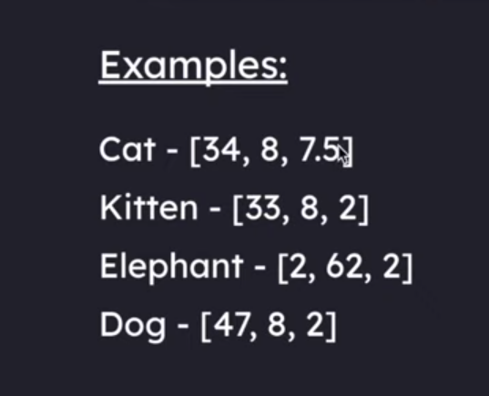
Similar items are closer to each other. Advantage of higher dimensional embedding model is it captures more semantic information about the text passage. Downside more expense to embed as well we store.
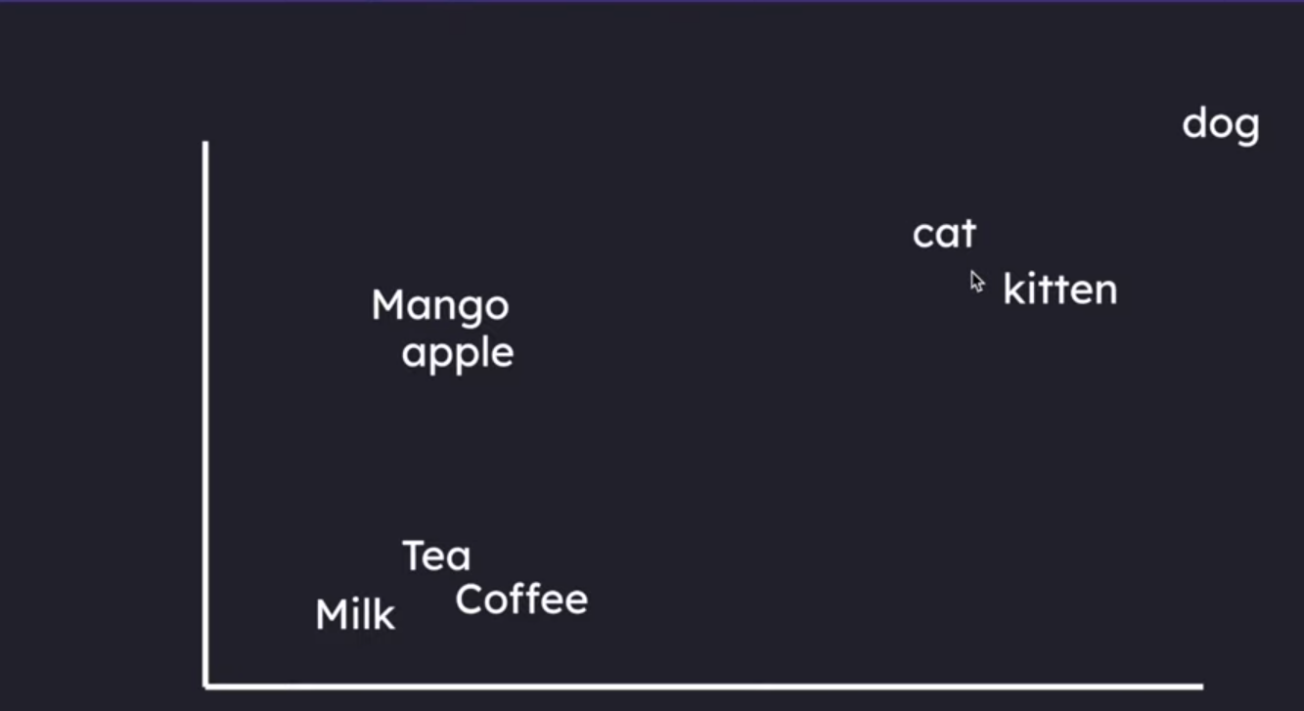
Popular Embedding models:
- OpenAI – text-embedding-3-small – 1536 dimensions
- OpenAI – text-embedding-3-large – 3072 dimensions
Vector DB: vector database is bult to store all vector embedding.

Process
- Knowledge base construction – Ingesting Pipeline. In RAG system, big source documents say 10M tokens are divided in chunking – Small set of tokens say 1K token each.
- Retrieval Pipeline – Pass through embedding model asl well and converted into vector representation. Retrievers will go through the Vector DB to compare the dimensions and choose top chunks from vector db and send them to LLM model to get answer. This will be English chunks and not vector. As vector is only used to compare and get dimensions.
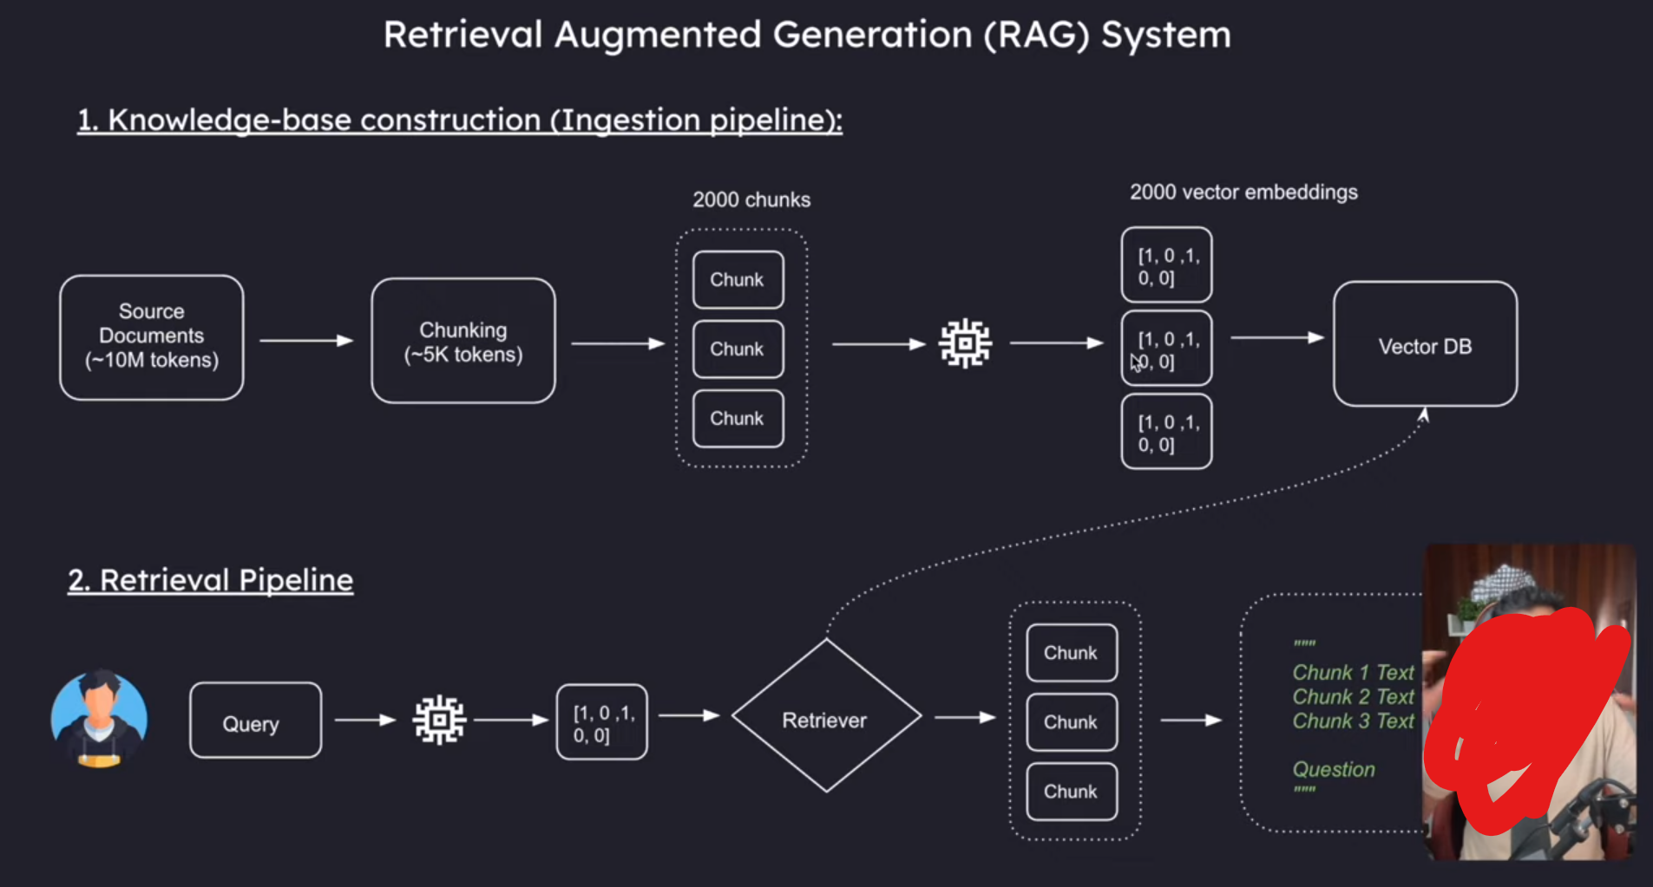
IMPORTANT – It is important to use same model for query and vector db. As different models act like different languages and cannot communicate or understand each other. Dimensions should always be same.

Cosine Similarity
Measures angle between vectors and not their magnitude.
Formula -> cosine = (A.B) / (||A|| X ||B||)
A and B are two vectors compared.
A.B => product of A and B
||A|| => magnitude (length) of vector A
||B|| => magnitude (length) of vector B
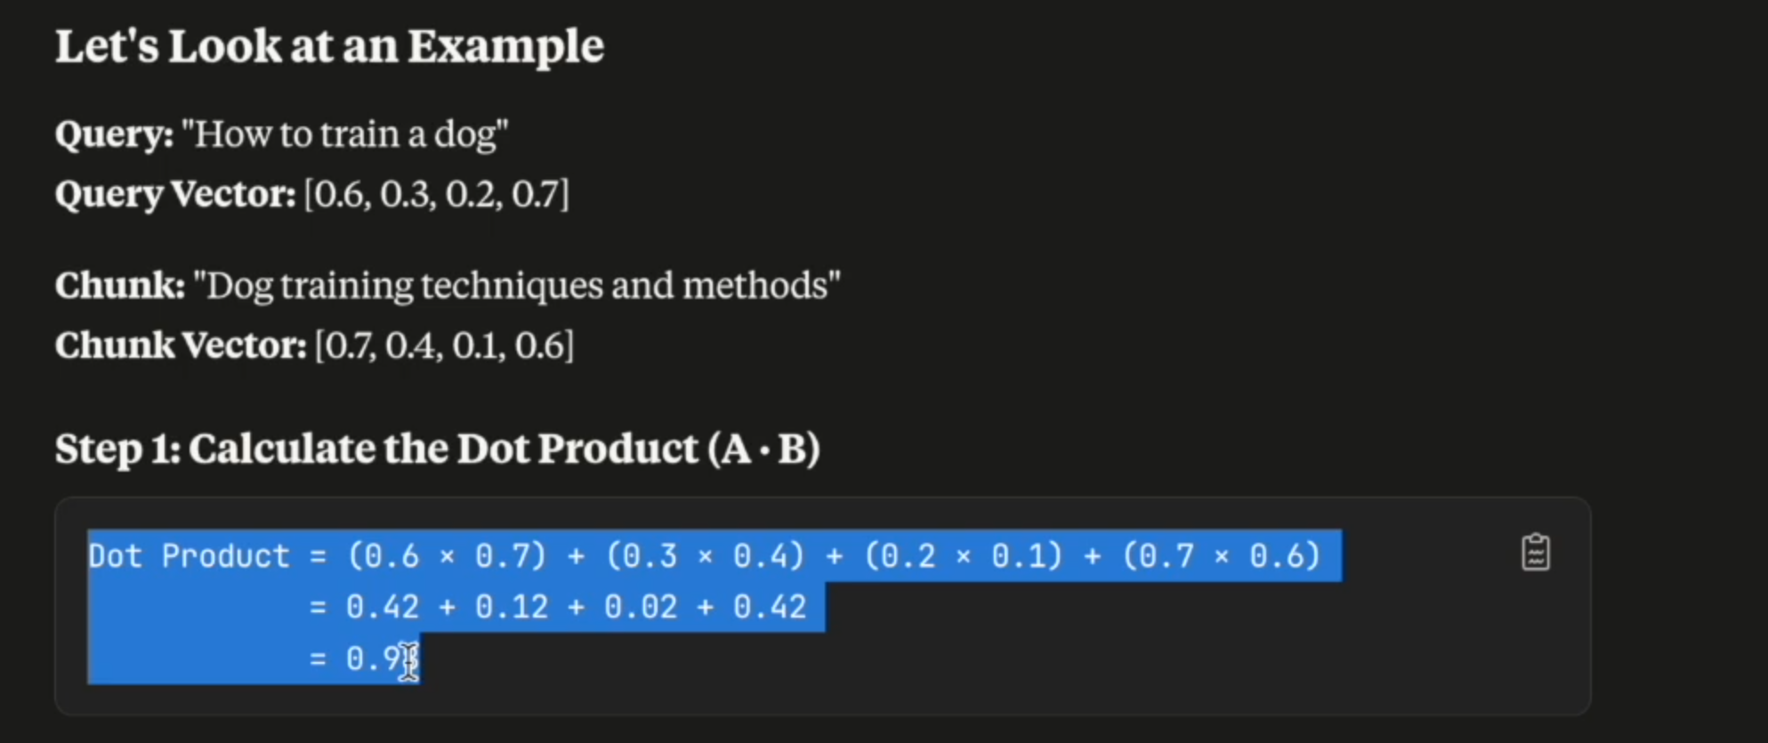

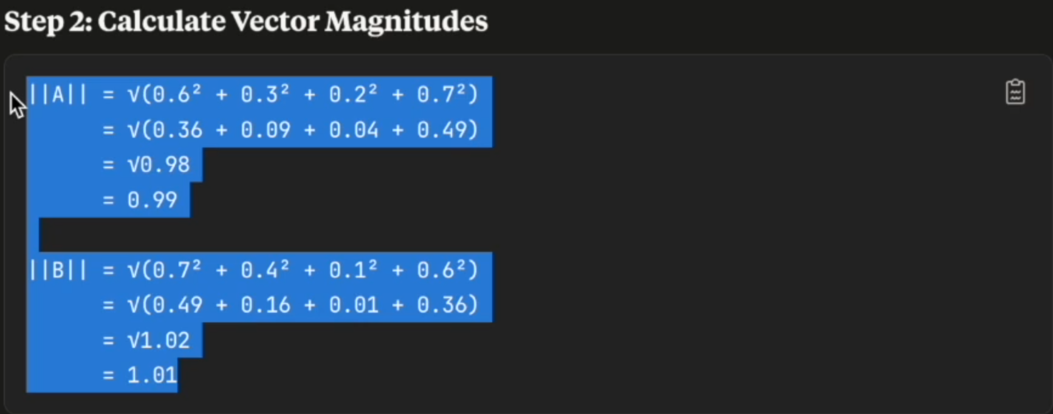
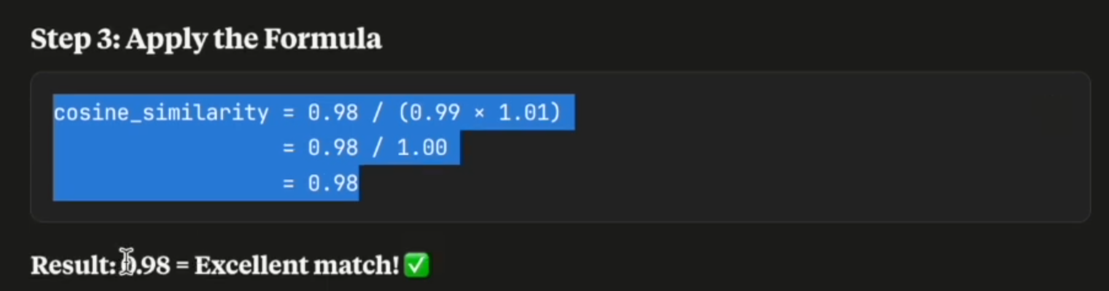
IMPORTANT:
